Mild HEV (48V mHEV) Auto Start-Stop Speed Threshold Control Function – CGEA1.3

Functional Description

This STSS handles the setting of the Automatic Engine Start/Stop speed threshold for a 48V Mild HEV vehicle (48V mHEV). The purpose of this setting is to mitigate TGW (avoid annoyance to customer) when Auto Engine Start Stop activates at a certain speed.

The ECM settings are accomplished using signals StopStrtVThres_D_Stat and StopStrtVThres_D_RqMnu.

Starting in MY2019 with U625/U611 the Settings are migrating from the cluster to Center stack. This STSS supports displaying settings in the cluster or configuring the cluster settings off if they are displayed in the Center stack. When configured for settings in the Center Stack, for this feature, the cluster acts as a signal gateway between the Center Stack and the ECM module. Any feature setting that the cluster acts as gateway for by definition only has one setting (i.e. the setting is not part of Enhanced Memory). Thus, the requested Index from the Center Stack is always just copied back in the IPC response.

The customer uses the message center switches and display to set the mHEV Auto Start Stop Speed Threshold settings in the vehicle when settings are in the cluster.

Interfaces

Interface Context Diagram (I/O Block Diagram)
Figure 1 mHEV Auto Start Stop Speed Threshold Function Context Diagram
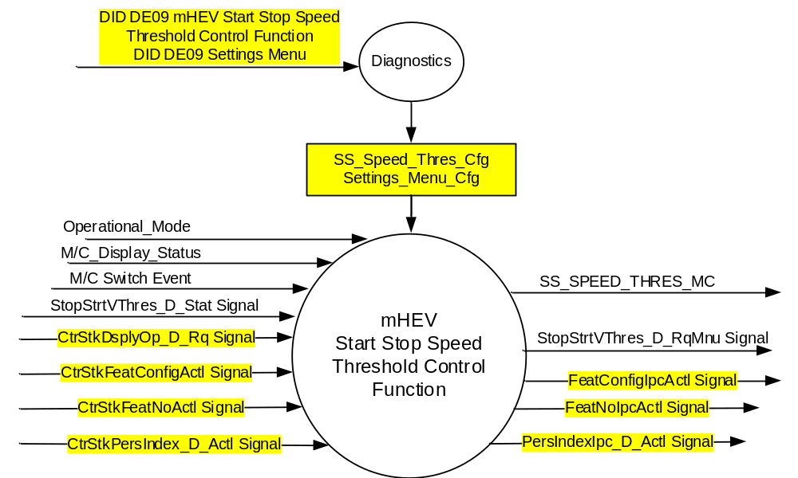

Inputs
- INTERNAL:
- Operational_Mode
- M/C Switch Event
- M/C_Display_Status
- SS_Speed_Thres_Cfg
- Settings_Menu_Cfg

- MUX signals on the CAN Bus from ECM

- StopStrtVThres_D_Stat Signal
Signal Name | Size (bits) | Detail | Units | Res. | Offset | State Encoded | Min | Max
StopStrtVThres_D_Stat | 2 |  | SED | 1 | 0 |  | 0  (0x0) | 3  (0x3)
 |  | NoSelection |  |  |  | 0 (0x0)
 |  | Low |  |  |  | 1 (0x1)
 |  | Medium |  |  |  | 2 (0x2)
 |  | High |  |  |  | 3 (0x3)

- MUX message on the CAN Bus from APIM:

- CtrStkFeatConfigActl Signal
Signal Name | Size  (bits) | Detail | Units | Res. | Offset | State  Encoded | Min | Max
CtrStkFeatConfigActl | 16 | - | Undefined | 1 | 0 |  | 0  (0x0) | 65535 (0xFFFF)

- CtrStkFeatNoActl Signal
Signal Name | Size  (bits) | Detail | Units | Res. | Offset | State  Encoded | Min | Max
CtrStkFeatNoActl | 16 | - | Undefined | 1 | 0 |  | 0  (0x0) | 65535 (0xFFFF)

- CtrStkPersIndex_D_Actl Signal
Signal Name | Size  (bits) | Detail | Units | Res. | Offset | State  Encoded | Min | Max
CtrStkPersIndex_D_Actl | 3 |  | SED | 1 | 0 |  | 0 (0x0) | 7 (0x7)
 |  | PERS_1 |  |  |  | 0x0
 |  | PERS_2 |  |  |  | 0x1
 |  | PERS_3 |  |  |  | 0x2
 |  | PERS_4 |  |  |  | 0x3
 |  | Vehicle |  |  |  | 0x4
 |  | Unused_1 |  |  |  | 0x5
 |  | Unused_2 |  |  |  | 0x6
 |  | Unused_3 |  |  |  | 0x7

- CtrStkDsplyOp_D_Rq Signal
Signal Name | Size  (bits) | Detail | Units | Res. | Offset | State  Encoded | Min | Max
CtrStkDsplyOp_D_Rq | 3 |  | SED | 1 | 0 |  | 0 (0x0) | 7 (0x7)
 |  | Null |  |  |  | 0x0
 |  | Query |  |  |  | 0x1
 |  | Set |  |  |  | 0x2
 |  | Upload |  |  |  | 0x3
 |  | Restore |  |  |  | 0x4
 |  | Copy |  |  |  | 0x5
 |  | Unused_1 |  |  |  | 0x6
 |  | Unused_2 |  |  |  | 0x7

Outputs
- SS_SPEED_THRES_MC
- MUX signals on the CAN Bus

- StopStrtVThres_D_RqMnu Signal
Signal Name | Size (bits) | Detail | Units | Res. | Offset | State Encoded | Min | Max
StopStrtVThres_D_RqMnu | 2 |  | SED | 1 | 0 |  | 0  (0x0) | 3  (0x3)
 |  | NoSelection |  |  |  | 0 (0x0)
 |  | Low |  |  |  | 1 (0x1)
 |  | Medium |  |  |  | 2 (0x2)
 |  | High |  |  |  | 3 (0x3)

- FeatConfigIpcActl Signal
Signal Name | Size  (bits) | Detail | Units | Res. | Offset | State  Encoded | Min | Max
FeatConfigIpcActl | 16 | - | Undefined | 1 | 0 |  | 0  (0x0) | 65535 (0xFFFF)

- FeatNoIpcActl Signal
Signal Name | Size  (bits) | Detail | Units | Res. | Offset | State  Encoded | Min | Max
FeatNoIpcActl | 16 | - | Number | 1 | 0 |  | 0  (0x0) | 65535 (0xFFFF)

- PersIndexIpc_D_Actl Signal
Signal Name | Size  (bits) | Detail | Units | Res. | Offset | State  Encoded | Min | Max
PersIndexIpc_D_Actl | 3 |  | SED | 1 | 0 |  | 0 (0x0) | 7 (0x7)
 |  | PERS_1 |  |  |  | 0x0
 |  | PERS_2 |  |  |  | 0x1
 |  | PERS_3 |  |  |  | 0x2
 |  | PERS_4 |  |  |  | 0x3
 |  | Vehicle |  |  |  | 0x4
 |  | Unused_1 |  |  |  | 0x5
 |  | Unused_2 |  |  |  | 0x6
 |  | Unused_3 |  |  |  | 0x7

Function/Performance

Operational Modes

Mode | Differentiating Vehicle Conditions
Sleep Mode | Start Stop Speed Threshold Control Function Text Messages Disabled
Limiting Mode | Start Stop Speed Threshold Control Function Text Messages Disabled
Normal Mode | Start Stop Speed Threshold Control Function Text Messages Enabled / Disabled
Crank Mode | Start Stop Speed Threshold Control Function Text Message Enabled / Disabled

Voltage Levels

Refer to the Cluster Features table located in the Operational Modes and Voltage Range Strategies Section in this SPSS.

Human-Machine Interface

Visual

Indicator Graphics / Display Format
For program specific display, refer to “<Program> Cluster Menu Structure.xls”.
Example Menu Graphics:

With SS_Speed_Thresh_Cfg = Enabled:

Menu Level 2 | Menu level 3 |  |  |  | Menu level 4
Vehicle |  | HEV Boost Sensitivity* |  | ❍ | High
 |  |  |  | ● | Medium
 |  |  |  | ❍ | Low
* Note Menu name is undecided at this time. Another possible name is “Engine Start/Stop Speed Threshold”.

Indicator Color Coordinates

Reference section COLOR & ILLUMINATION REQUIREMENTS (GRAPHICS)

Indicator Characteristics

Refer to Message Center X Display_Y Button Interface Section, where X and Y are appropriate values in this document.

Audio

None

Switch Control Logic

Consumer access to this Control Configuration shall be as specified in the message center basic functionality display as specified in Message Center X Display_Y Button Interface Section, where X and Y are appropriate values in this document.

System Accuracy

Within a 100msec of receiving a message that results in a change of state the cluster will update the display to the proper status.

Operation: Performance and Functional

Subsystem Algorithm Flowchart / State Diagram

Figure 2 SS Speed Threshold Diagnostic Configuration Flowchart
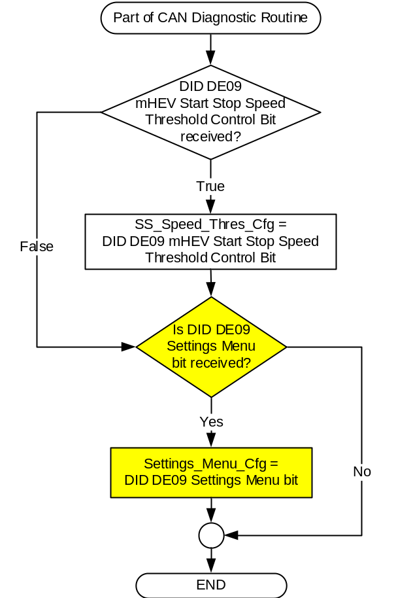

Figure 3: SS Speed Threshold ECM input request Flowcharts

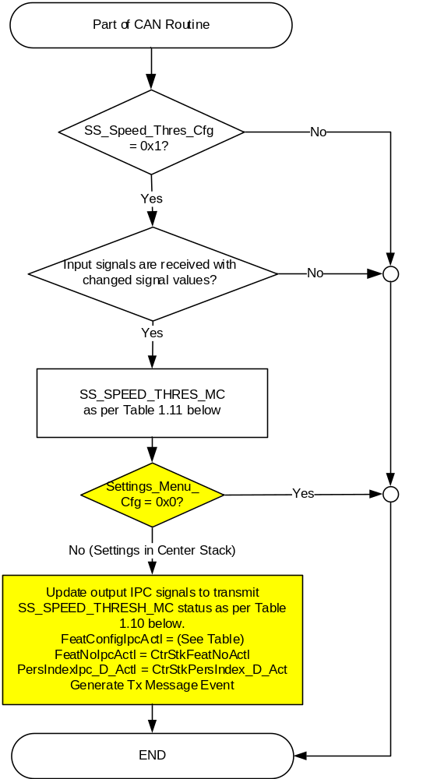

Figure 4. SS Speed Threshold Centerstack Signal Gateway Routine Flowchart
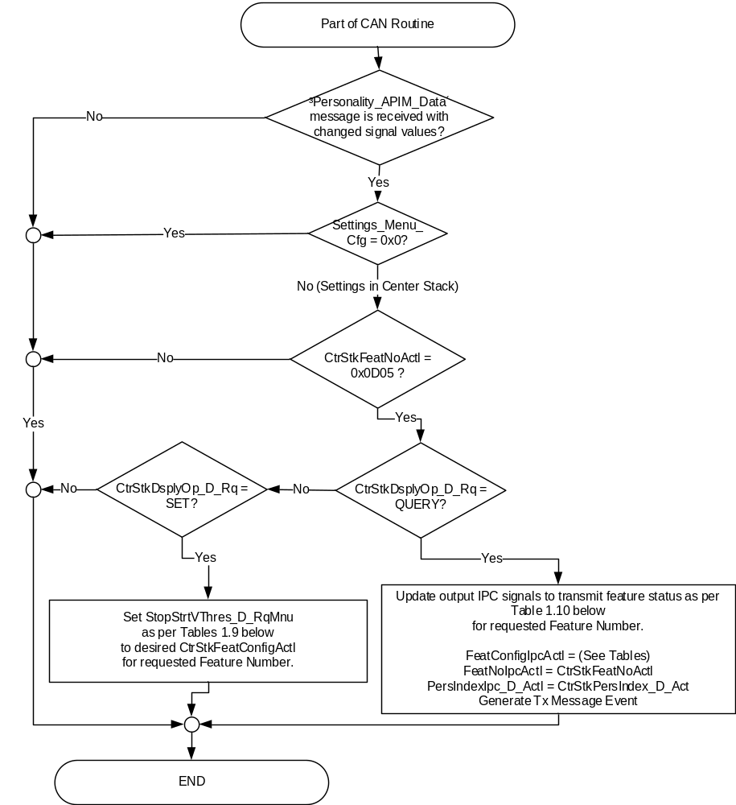

- StopStrtVThres_D_RqMnu State based upon CtrStkFeatConfigActl
CtrStkFeatNoActl Signal | CtrStkFeatConfigActl  Signal | Display Menu  In Center Stack (For reference) | StopStrtVThres_D_RqMnu Signal
0x0D05 | Low (0x1) |  | 0x1 (Low)
  ❍ | High
  ❍ | Medium
  ● | Low
0x0D05 | Medium  (0x2) |  | 0x2 (Medium)
  ❍ | High
  ● | Medium
  ❍ | Low
0x0D05 | High  (0x3) |  | 0x3 (High)
  ● | High
  ❍ | Medium
  ❍ | Low
0x0D05 | Unused (0x0, 0x4 -0xFF) |  | 0x0 (NoSelection)
  ❍ | High
  ❍ | Medium
  ❍ | Low

- FeatConfigIpcActl State based upon SS_SPEED_THRES_MC _Status_Flag
SS_SPEED_THRES_MC | Display Menu  In Center Stack  (For reference) | CtrStkFeatNoActl  Signal | FeatConfigIpcActl  Signal
Low (0x1) |  | 0x0D05 | Low (0x1)
  ❍ | High
  ❍ | Medium
  ● | Low
Medium  (0x2) |  | 0x0D05 | Medium  (0x2)
  ❍ | High
  ● | Medium
  ❍ | Low
High  (0x3) |  | 0x0D05 | High  (0x3)
  ● | High
  ❍ | Medium
  ❍ | Low
Error  (0x4) |  | 0x0D05 | Not Used  (0x0)
  ❍ | High
  ❍ | Medium
  ❍ | Low

Figure 5: SS Speed Threshold ECM output SET request Flowchart

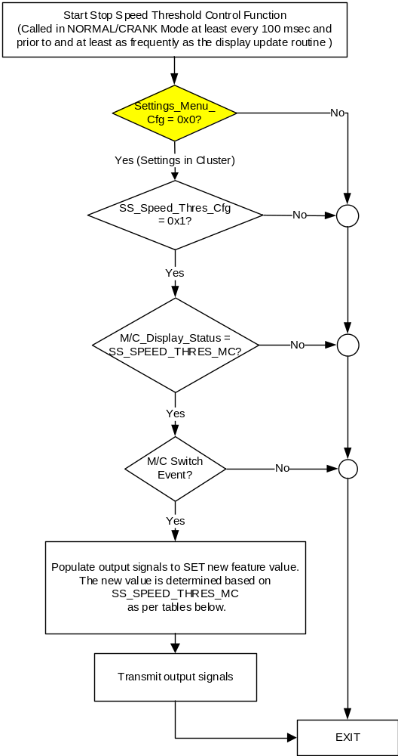

NOTE: In the above Control Function Flowchart, the definition of "M/C Switch Event" is defined in Message Center X Display_Y Button Interface Section, where X and Y are appropriate values in this document.

- SS_SPEED_THRES_MC State Assignment
StopStrtVThres_D_Stat | SS_SPEED_THRES_MC
0x0 (NoSelection) | Error  (0x4)
0x1 (Low) | Low  (0x1)
0x2 (Medium) | Medium  (0x2)
0x3 (High) | High  (0x3)
Missing per Section 1.4.1 | Error  (0x4)

- Message Center Display and MC ECM Request Messages

based upon Table SS_SPEED_THRES_MC
SS_SPEED_THRES_MC | Display Menu | 5-Button Switch Selection Event | StopStrtVThres_D_RqMnu Signal
Low  (0x1) |  | Up/Down + OK (Select Medium or High) | 0x2 (if Medium is selected)  0x3 (if High is selected)
  ❍ | High
  ❍ | Medium
  ● | Low
Medium  (0x2) |  | Up/Down + OK (Select Low or High) | 0x1 (if Low is selected)  0x3 (if High is selected)
  ❍ | High
  ● | Medium
  ❍ | Low
High  (0x3) |  | Up/Down + OK (Select Low or Medium) | 0x1 (if Low is selected)  0x2 (if Medium is selected)
  ● | High
  ❍ | Medium
  ❍ | Low
Error  (0x4) |  | Up/Down + OK (Select Low or Medium or High) | 0x1 (if Low is selected)  0x2 (if Medium is selected)  0x3 (if High is selected)
  ❍ | High
  ❍ | Medium
  ❍ | Low

Operation Description (supports algorithm flowchart /state diagram)

- Personalization Feature Number Definition:
Feature Name | Feature Num | Cfg Num | Cfg Value
HEV Boost Sensitivity / Engine Start Stop Speed Threshold (Mild Hybrids 48V) | 0x0D05 | 0x0 | Undefined / Not Used / Off
 | 0x0D05 | 0x01 | Low
 | 0x0D05 | 0x02 | Medium
 | 0x0D05 | 0x03 | High

Function Safety Classification (EMC)

Class B

Memory Storage
Parameter Name | Description | Value at  Battery Connect | Value at  Module Wake-up
SS_SPEED_THRES_MC | Output displayed in the M/C for mHEV Auto Stop Start Speed Threshold setting in Menu. | Disabled (0x0) | Do Not Init
StopStrtVThres_D_RqMnu Signal | Output signal to ECM. This signal only changes when the user makes a menu selection. | No_Selection (0x0) | No_Selection (0x0)
SS_Speed_Thres_Cfg | Configures cluster to allow mHEV Auto Start Stop Speed Threshold menu to be displayed. Set to Disabled at Cluster Supplier Manufacturing Plant. | Use Stored Value | Use Stored Value
M/C_Display_Status | State Indicator to identify which text is currently being displayed on Message Center display. See * | See * below | See * below
M/C Switch Event | Event that is indicated as per the switch interface for the Message Center. See * | See * below | See * below
Operational_Mode | 4 state indicator for cluster operational mode | Limited | Limited, Normal or Crank
* Refer to Message Center X Display_Y Button Interface Section, where X and Y are appropriate values in this document.

Reconfigurable Telltale

Not Applicable

Prove Out

Not applicable

Message Center Msg

None

Error Handling

Missing Message Strategy

The signals will be declared missing as per the Diagnostics section of this SPSS.

DTCs states and history will be determined as per the Diagnostics section of this SPSS.

If SS_Speed_Thres_Cfg = Disabled, the cluster shall never log a missing message for this feature.

Diagnostics

Self Test

None

Engineering Test Mode

Reference section “Dealer / Engineering Test Mode (ETM)”

Part II Performance

Supported Diagnostic Trouble Codes (DTCs)
DTC | Description
C10000 | Lost communication with ECM/PCM

DID DExx:
Block  Num | Block Description | Byte(s) | Bits | State: Description | "0" | "1" | Default | Comments/Information
PACKETED BLOCKS
$09 | Option Content (B&A) | * | * | mHEV Start Stop Speed Threshold Control Function | Disabled | Enabled | Disabled | This parameter allows the menu choice for the mHEV Start Stop Speed Threshold Menu to be displayed in the cluster settings menu or Center Stack (since cluster is signal gateway for this feature). Menu display is determined by Settings Menu config.  This is currently planned for use only on 48V Mild HEV vehicles.  Disabled means both message center and Center Stack setup feature is not present in the vehicle.
$09 | Option Content (B&A) | * | * | Settings Menu | Cluster | Center Stack | Cluster | This parameter allows the Settings menu to be displayed in the cluster when 0x0. When 0x1, the expectation is that settings are displayed in the Centerstack. For this feature (when 0x1), the cluster will remove almost all items from settings menu. (Cluster display choices remain). Note this is a global config, each feature still has its own config for presence on vehicle.
 | *Byte and bit location to be identified in Part II Specification for this cluster

Reference Specification

None.

Revision History
SPSS Module Revision History
Revision Level | Name | Change Description | Date
1.0 | S. Watkins | Initial release. Feature owner is Pablo Fernandez sanchez. Lead program is V363 MCA. DI Forum Date 4/15/2016. | 6/12/2017
2.0 | S. Watkins | Starting in MY2019 with U625/U611 the Settings are migrating from the cluster to Centerstack. This STSS update is to support this effort. A configuration is added to ensure backward compatiblity.  This was approved offline and is documented in the DI CC minutes of 8/10/2017.  - Engine Start Stop Speed Threshold Approval to update cluster feature spec Daniel Menchaca  Approved to update cluster feature spec – Update cluster feature spec to accommodate Settings to SYNC.  Changes shown in yellow:  - Section 1.1 – Updated description  - Section 1.2.1 – Added a config, 4 input signals and 3 output signals  - Section 1.2.2 – Added Setting_Menu_Cfg and 4 new signals  - Section 1.2.3 – Added 3 new signals  - Section 1.3.5.1, Figure 2 – Added Settings_Menu_Cfg. Modified Figure 3 to add decision diamond for Settings_Menu_Cfg. Added all new Figure 4. Added new Table 1.9 and Table 1.10. Modified Figure 5 to add decision diamond for Settings_Menu_Cfg.  - Section 1.3.5.2 – Added Table 1.13 Feature Number definition for HEV Boost Sensitivity / Engine Start Stop Speed Threshold.  - Section 1.5.3 – Modified description of existing configs and added new Settings Menu config to DExx. | 8/11/2017

